**ANALYSIS OF USDA DATA FOR NORTH CAROLINA BETWEEN 2012 & 2017.**

**KEY FINDINGS**

1. **Commodities that had the Highest Measured Value In 2012 And 2017.**

1. **Commodities that had the Highest Percentage Increase in Values Between 2012 And 2017?**

1. **Map Eyeballing Counties with Highest Increase and Decrease in Percentage Change in Value for Each Commodity.**

**Map Generated For Feed**

**Map Generated For Fuel**

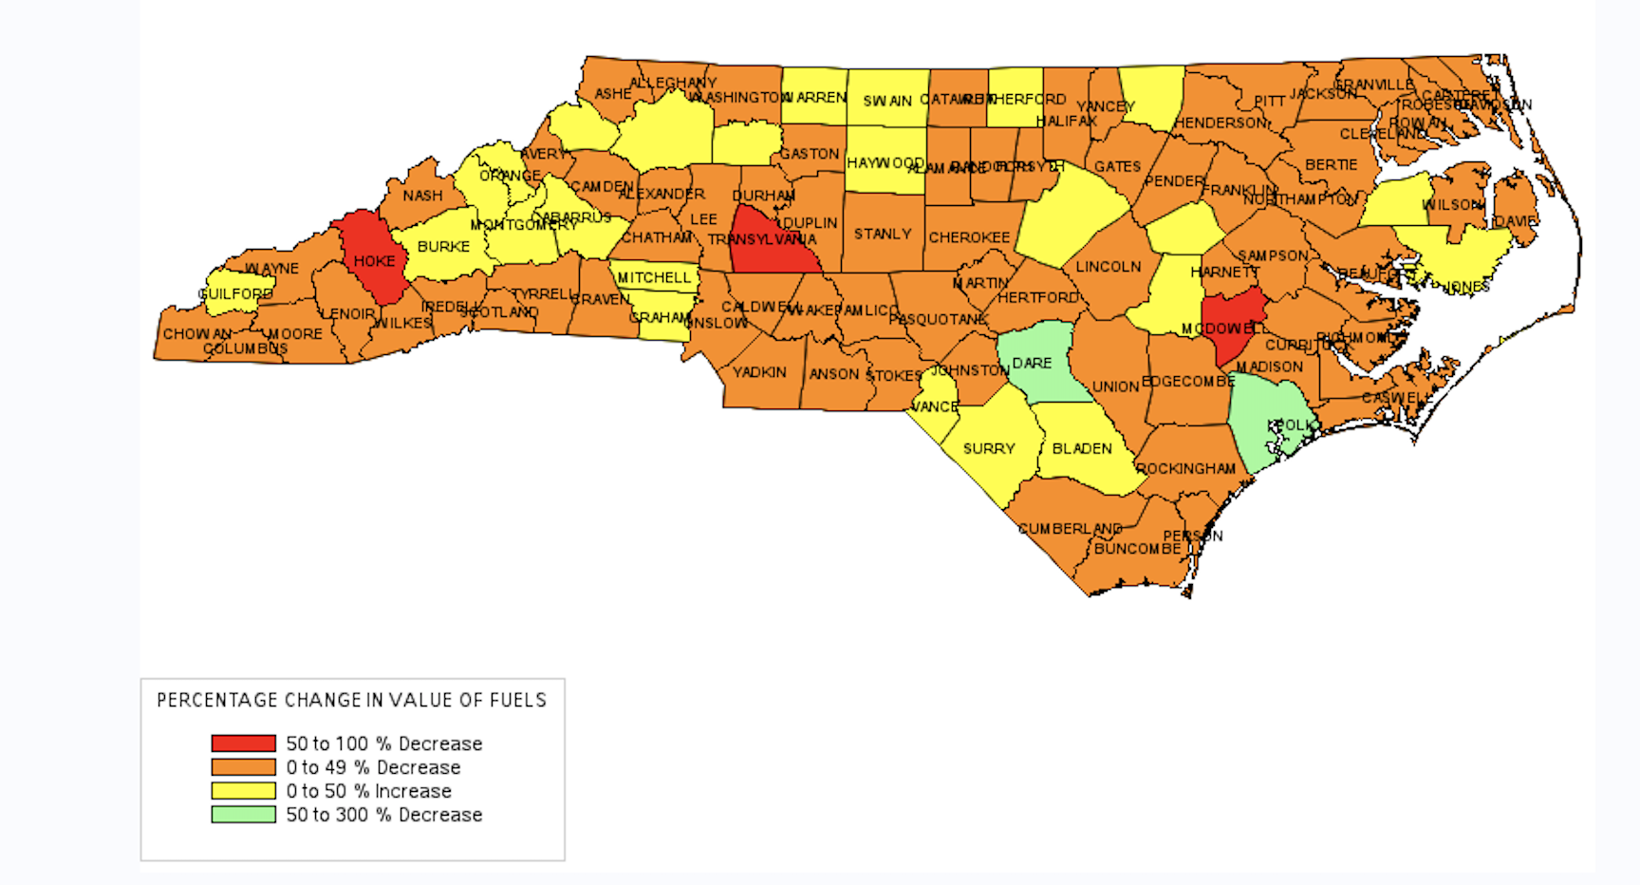

1. **Summary Statistics Showing Each Commodity’s Percent Change in Value and Other Variables Between 2012 & 2017.**

**Summary Statistics For Feed.**



**Summary Statistics For Fuel.**

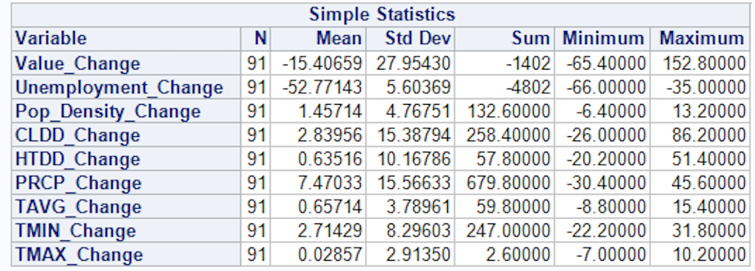

1. **Correlation Matrix of Each Commodity’s Percent Change in Value.**

**Correlation Matrix of Percent Change in Value & for Fuel**

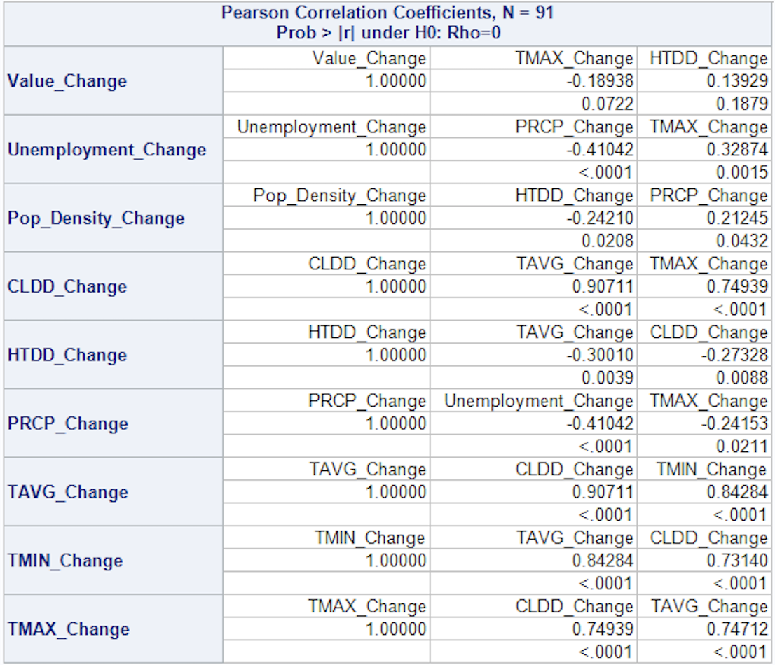

**Correlation Matrix of Percent Change in Value for Feed**

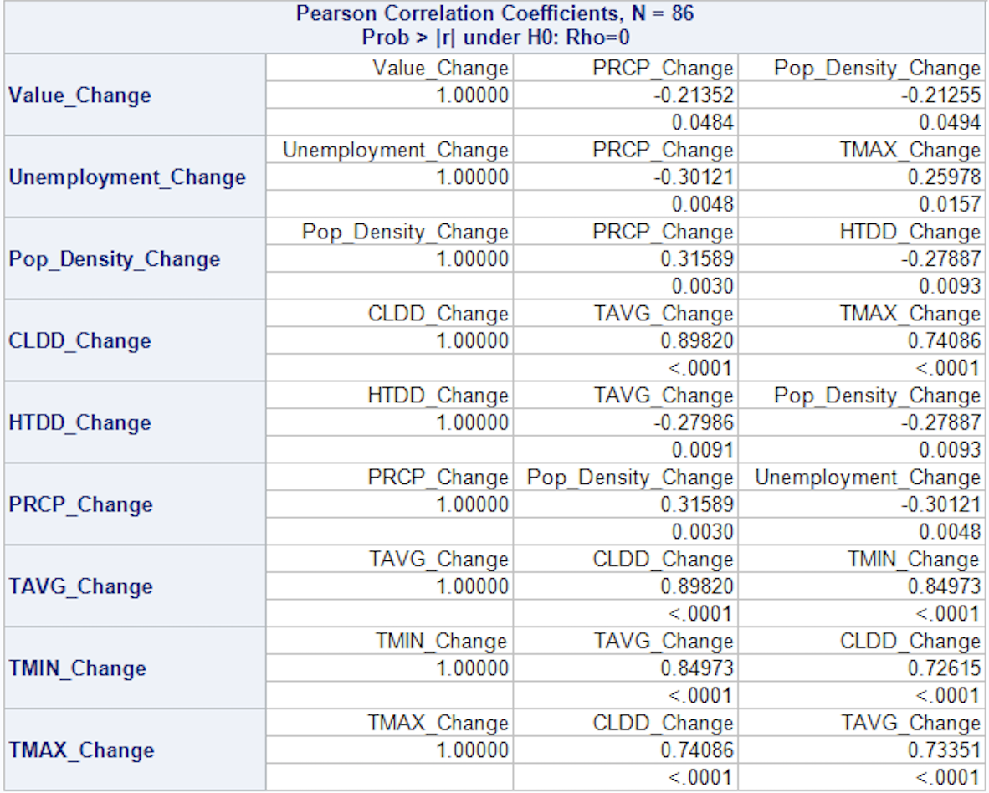

1. **Linear Regression Model to Predict Change in Value of Each Commodity Using The Top 2 Predictive Variables.**

Note: Each Commodity Has Different Top Predictors.

**Below Is A Linear Regression Model for Feed With % Change in Population Density And % Change In Unemployment Rate As Top Predictive Variables.**

**Below Is A Linear Regression Model for Fuel With % Change in Population Density And % Change In Unemployment Rate As Top Predictive Variables.**

